Member Admin Form - Requirement Gathering II – May 17, 2020

Proposed form:11111

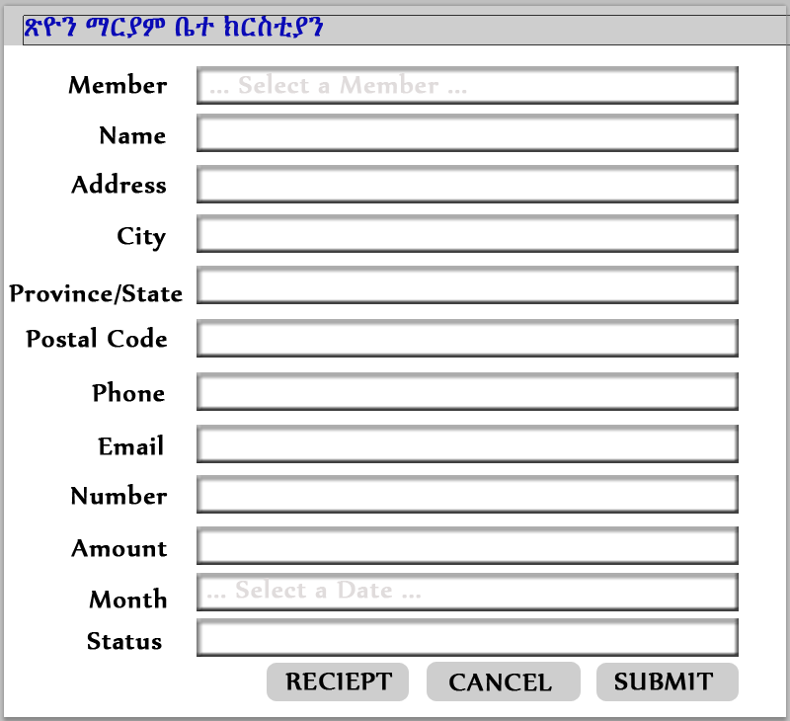

Stakeholder comments:

After viewing the designed form, can you give me specific ideas of what you have?

1. I need a page where I can choose to add new member, delete member, update member information,
2. I need a log in page with username and password

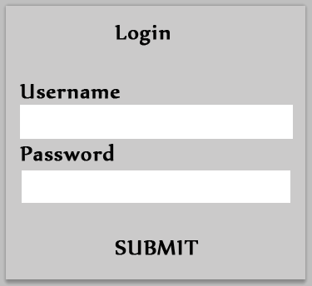

1. I need a page to submit membership payment

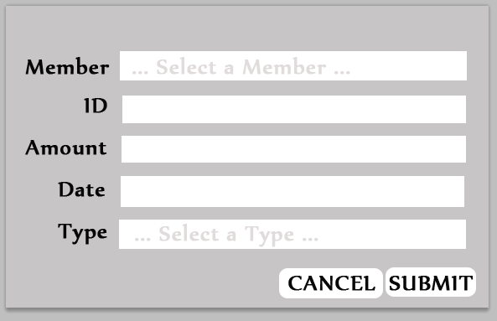

1. I need to run weekly, bi-weekly, monthly or annually report on:
   1. Membership List
   2. Membership Status
   3. Membership Payments
      1. Monthly Dues
      2. Asrat
      3. Silet
   4. report page to show existing members (search for member)